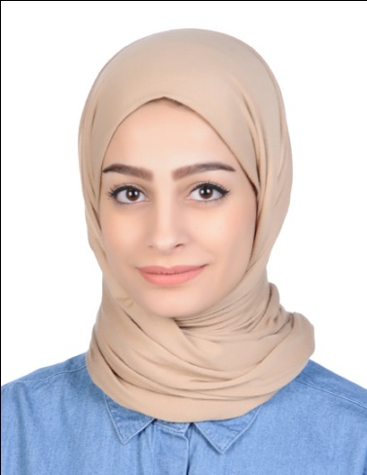



* **Present: Studying ACCA since august 2017 , Finished F1, F2, F3, F5 and F7 so far.**
* **2013/2014 :**

Bachelor degree in Business Administration from the University of Bahrain with GPA 3.76%.

* **4/6/2014:**

TOEFL certificate with score 101.

* **11/5/2014:**

Completed a preparation for TOEFL IBT course at American Cultural Educational Centre.

* **2009/2010:**
* Completed 1 course in the degree level in Bahrain Polytechnic which included Marketing, Accounting and English subjects.
* Foundation studies 1&2 from Bahrain Polytechnic in business which included basic business studies, English, data analysis, IT and academic skills.
* **2008/2009:**

Secondary school certificate from Al-Noor secondary girls' school with GPA 97.1%.

* **(Feb 24,2014 to 30 april 2018 ): Administrative assistant in Creative Design co “Accounting department”:**
* Handling petty cash funds.
* Bank reconciliation.
* Preparing cheques using Peachtree accounting system.
* Purchases, payments and bills entry using Peachtree accounting system.
* Data auditing.
* Filing.
* **(7-7-2013 to 22-8-2013):** Finished an internship Program in Investcorp Bank and experienced working in different departments which were the following: Operations and internal control, technology, hedge Funds, corporate investment in the Middle East and legal and compliance department.
* **Golden line advertising centre (July 1, 2009 to September 15, 2009)**
* Entering data in databases.
* Making calls to potential customers.
* Attending meetings with customers.
* Valid driving license.
* Computer skills:
* Microsoft office word.
* Microsoft offices excel.
* Microsoft offices Powerpoint.
* Windows movie maker.
* Peachtree accounting system.
* The ability to write read and speak Arabic and English fluently.
* The ability to learn fast and self motivated.
* The ability to communicate with clients.
* The ability to use most of office equipments.
* The ability to type fast in both languages.

**Skills**

To work in a productive environment with the opportunity to learn, earn and have experience in the working area, applying my qualities for the betterment of the organization.

**Objectives**

Date of birth: 9/1/1991

Mobile: 33386444, 33388872

Email: [Hawra.Habib@gmail.com](mailto:Hawra.Habib@gmail.com)

Address: House 1624, Road 4148, Block 541, Bani Jamrah, Bahrain

**PersonalInformation**

**Qualification**

**Hawra’a Abd Ali Ebrahim**